Food Chains
Use the words below to fill in the gaps in the sentences about food chains.
Herbivores Green plants Water Secondary Dogs Bacteria Photosynthesis Arrows Energy source Rabbits Carbon dioxide Consumers Carnivores Decomposers Producers Primary
A food chain is a sequence of who eats whom in a biological community. It starts with an __________ __________ , like the sun. The __________ in the chain show the flow of food energy.
Every community must have a food source, which is made by organisms called ___________ . Most producers are __________ __________ , such as flowering plants, moss and algae.
Producers make food using a process called _______________ . The plants use the energy from the sun to change __________ __________ and __________ into a sugar called glucose.
Organisms that require a ready-made source of food are called ___________ . Animals that eat producers are called ____________ consumers, or ____________ . Some examples are ____________ and cows.
Animals that eat other animals are called ______________ consumers or ____________ . Some examples are lions and ________ .
Fungi and __________ are organisms that break down wastes and dead bodies. These organisms are called _______________.

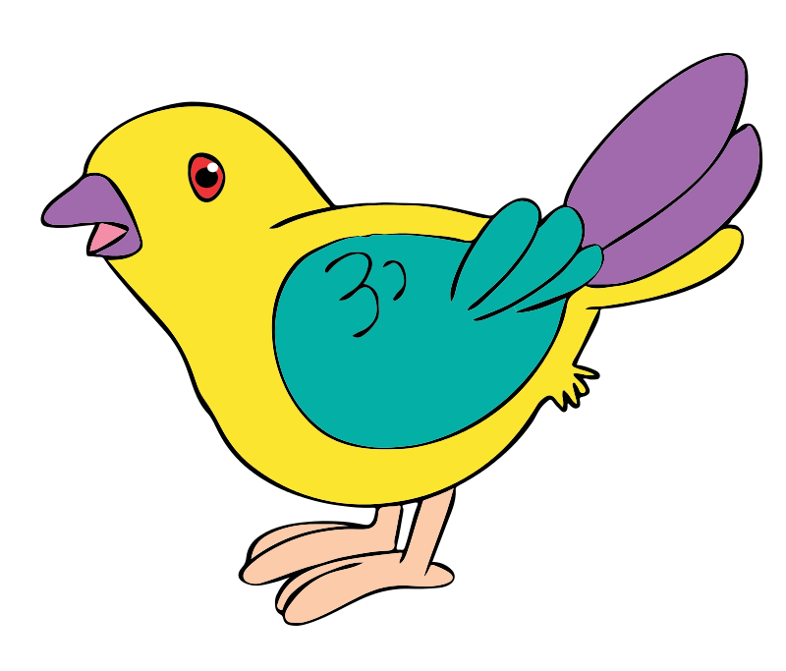
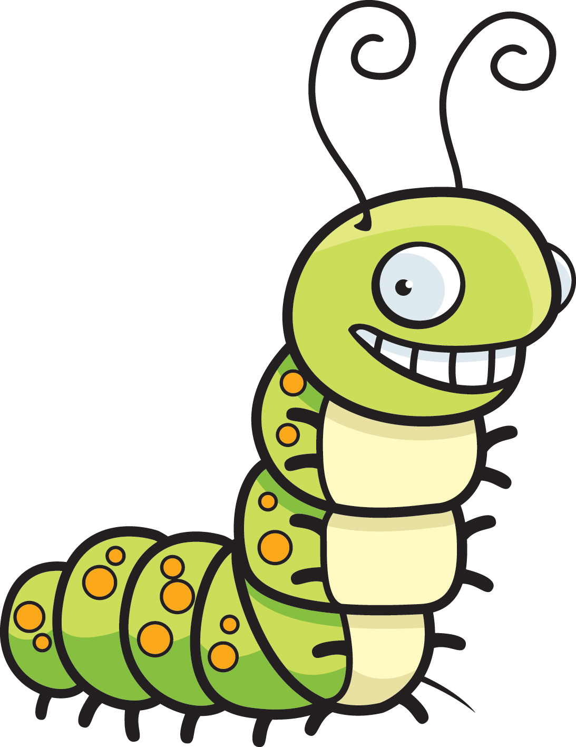
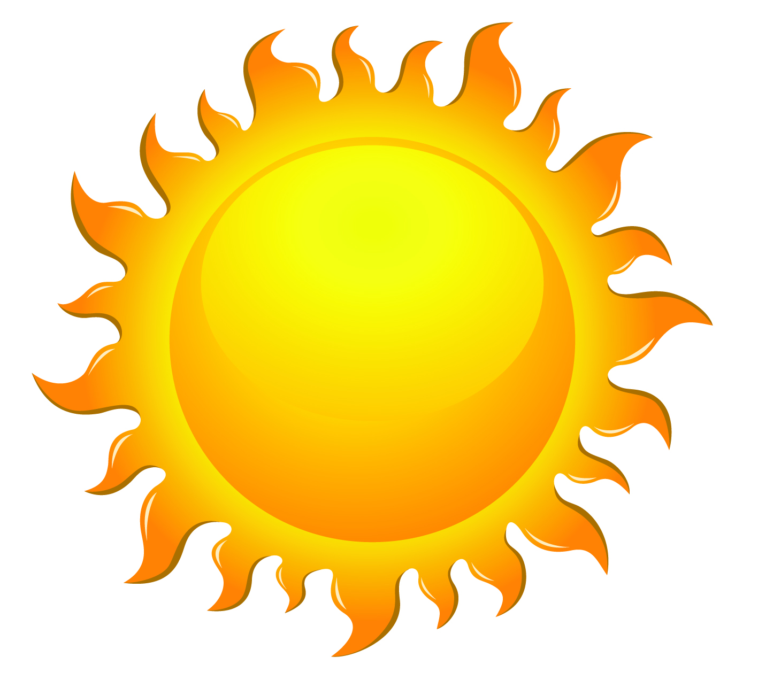
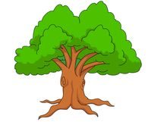
Use the food chain below to answer the questions.

Sun Tree Caterpillar Bird
- Identify the herbivore.
- What is the energy source?
- Which animal is the secondary consumer?
- Which organism is the producer?
- Identify the primary consumer?
- Which organism is the carnivore
Food Webs
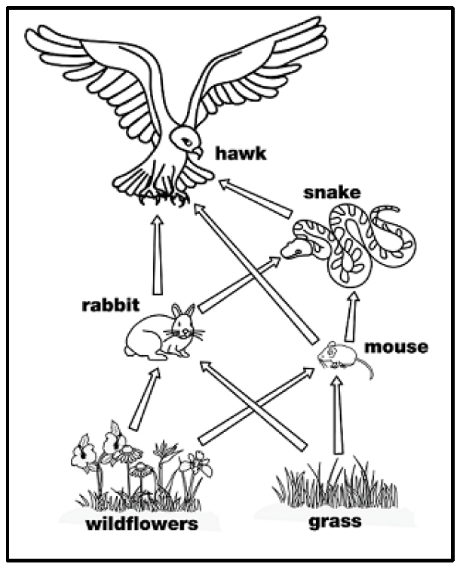
There are many food chains in communities and they are all interconnected. All the connected food chains are known as a food web. Food webs are usually complex, with each organism appearing in many food chains.

- Name the living things in the food web that are producers.
- List the primary consumers in the food web.
- Name the secondary consumers in the food web.
- There are many food chains in this food web. One chain with four levels is shown below.
Wildflowers Mouse Snake Hawk
Draw three more food chains, one with three levels and two with four levels.

Drawing Food Webs
Draw the following food webs. You can use words only or include pictures in your webs. Draw arrows between the organisms to show how the energy flows through the food web.
Web 1
- Grass provides food for snails and rabbits.
- Rabbits are eaten by foxes and snakes.
- The snails are eaten by birds.
- Birds, rabbits and snakes can be eaten by hawks.

Web 2
- Grass is eaten by a number of animals including rabbits, grasshoppers and mice.
- Grass hoppers provide a great meal for toads, mice, sparrows and snakes.
- Hawks feed on rabbits, sparrows and snakes.

Web 3
- In a pond, algae grow on rocks, which are eaten by water snails.
- The water snails are eaten by small fish, which also eat water plants.
- Large fish feed on both the snails and the small fish.

Web 4
- Trees produce acorns which act as a food for many mice and insects.
- Because there are many mice, the weasels and snakes have food.
- The insects and the acorns also attract birds and possums.
- With the possums, weasels and mice around, hawks, foxes and owls can find food.

Web 5
- Krill are small shellfish which live in the ocean.
- Krill are eaten by seals and fish.
- Seals are eaten by arctic wolves and polar bears.
- Polar bears also eat fish.

